ABP Server Bounce

Problem Statement

ABP Server Bounce Procedure After HF or Code Deployment from INV/AR
Whenever a hotfix (HF) or code is deployed to the environment from either the INV or AR side, it becomes necessary to bounce the ABP server. To perform this, we navigate to the following directory:
“/users/gen/abpwrk1/JEE/ABPProduct/scripts/ABP-FULL”
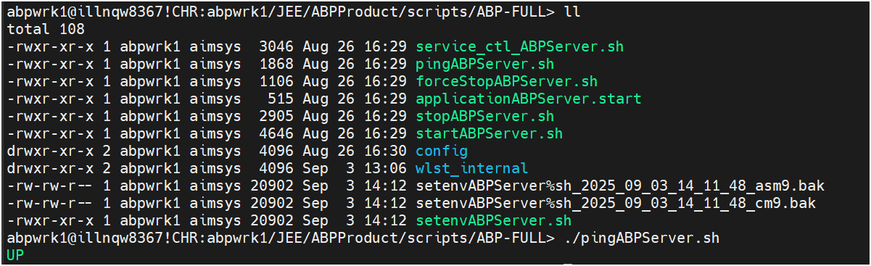

From there, we execute a force stop followed by a start of the ABP server to complete the bounce process. After initiating both commands, we use the “./pingABPServer.sh” script to check the server status and verify whether the ABP server is up or down.

However, since the ABP server can take anywhere from 5 to 30 minutes to come up—most commonly around 15 to 30 minutes—we often find ourselves repeatedly running the status check script. This makes it difficult to know exactly when the server is back online, especially if it comes up earlier than expected.
To streamline this process, I created a shell script that automates the status checking, helping us monitor the server more efficiently without manual intervention.

Process Flow: -

Step 1 [ Command Is Executed ]: -

When running “serverBounceCheck.sh” file in the unix system in the home directory.
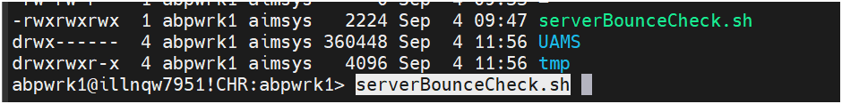

Step 2 [ Check Space In ENV ]: -
Currently, It checks according to the space provided in the env via the script. When space is greater than 95%, Then error message will be populated and it will break out of the shell script.
In case the space is in between 81% to 92% then it will show warning and continue the script.
Finally, if the space is less than 81% then it will show space available and proceed with execution of script.

Case 1: -
For Example:
If the total space in ENV is 45%
Currently Space in ENV is 44%
So, the below error message will be populated and shell script file will exit. There is also an option to clean the logs and it will automatically rerun the SH file.
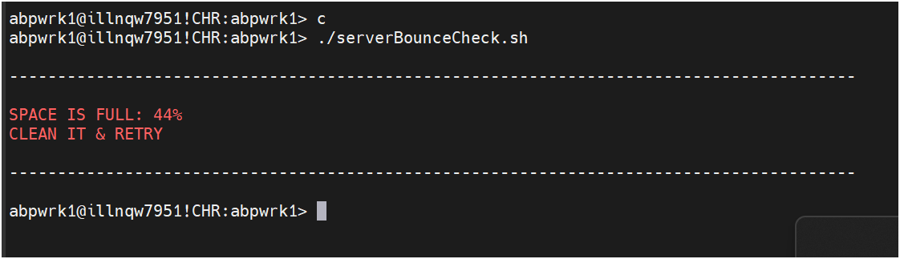

Case 2: -

For Example:
If the total space in ENV Is 50%
Current space in ENV Is 44%
if the space is between 38% to 45% and max space which the env can have is 50%, then a warning message will be in the response but the shell script file will still continue its execution.
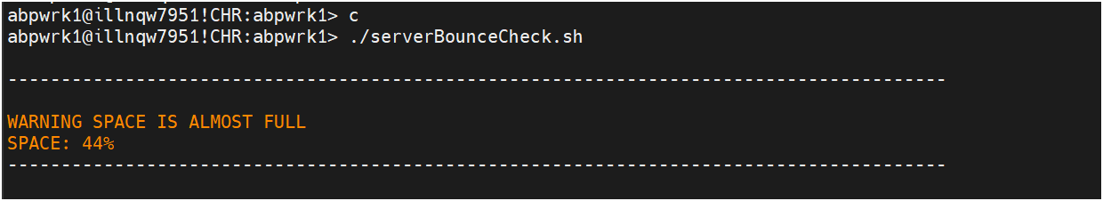

Case 3: -

In case the space is below let’s say 45% and the total space is 100%, then the success message will be populated and remaining SH file will continue to get executed.
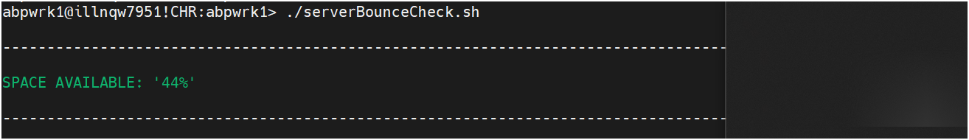

Step 3 [ Shuts down the ABP server ]: -

It stops the ABP server from the back end.
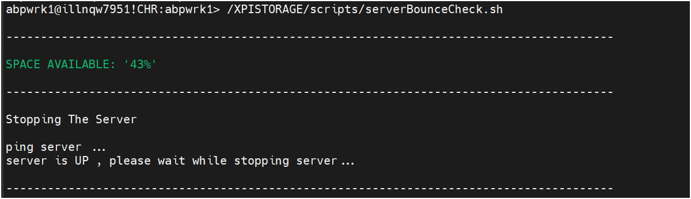

Step 4 [ Launches the ABP server]: -

Once the stop ABP server command is completed, It will start the ABP server.
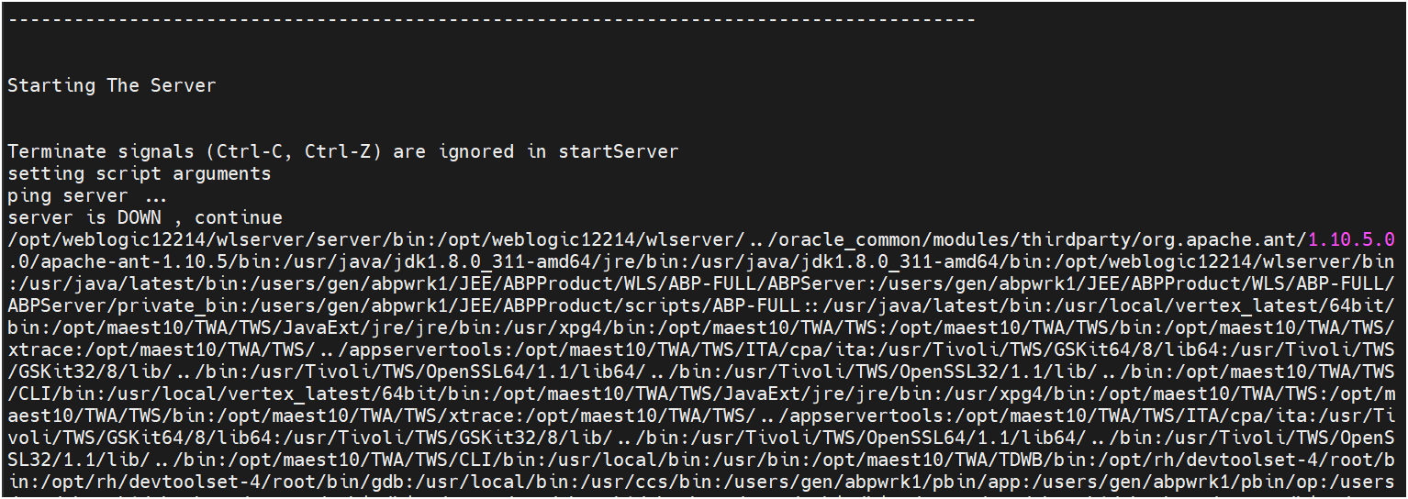

Step 5 [ Status Of ABP Server ]: -

Once the start ABP Server command is completed. It will start continuously checking the status of ABP Server and print respective message.
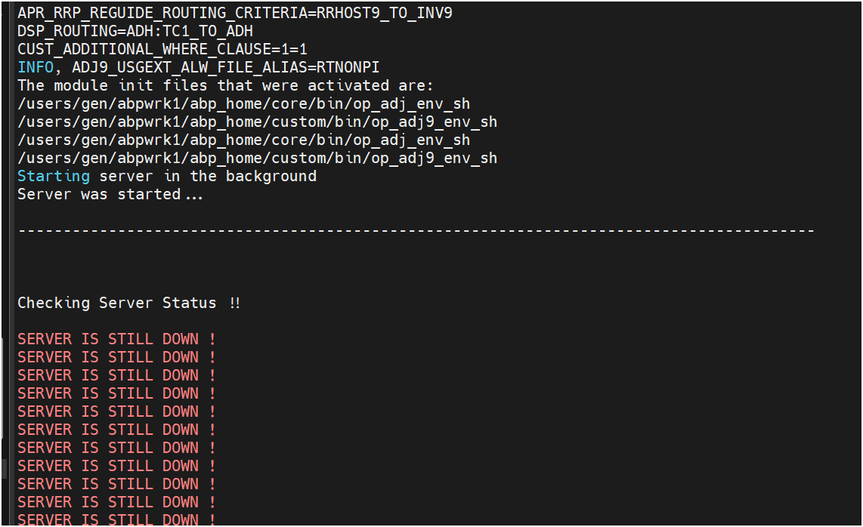


Step 6 [ ABP Server Is UP ]: -

Once the server is up, It will stop the SH file at this point.
